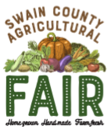
Swain County Agricultural Fair
Youth Division
Arts & Crafts Entry Form

Saturday, August 17, 2019

Youth’s Name: ____________________________________ Youth’s Age: _______
Address: ________________________________________ Phone #: ___________ Parent’s Name: ______________________________ E-mail: __________________

Division: A, B, or C | Class: 1, 2, 3, 4, or 5 | Category #

Entry Check-in
August 13: 8:00 am – 6:00 pm & August 14: 10:00 am – 5:00 pm
(any entry received after these dates will not be judged)

Entry Pick-up
August 19: 10:00 am – 5:00 pm
(unless items will be entered in the Mtn. State Fair & picked up by the Pony Express)

For more information, contact:
Jennifer Hill, Extension 4-H Agent
(828) 488-3848 OR jrhill9@ncsu.edu

