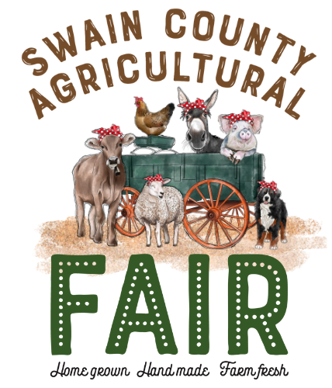
SWAIN COUNTY
AGRICULTURAL FAIR
Saturday, August 19, 2023

Farm Product Entry Form
Garden Vegetables, Fruits, Eggs & Flowers

Name: _______________________ Address: _______________________________ Phone #: ___________________ E-mail: ___________________________________
YOUTH ONLY: Age: _________ Parent’s Name: ______________________
Youth Division  A, B, C, D | Adult Division  E | Product Class:  Vegetable, Fruit, Eggs, Flowers | Category #:  8001A - 8021 | Other Details  (amount, specific type)

Entry Check-in
Friday, August 18, 2023 | 1:00 pm - 5:30 pm
(any entry received after 5:30 p.m. will not be judged)

All unclaimed produce will be given away or thrown away at the end of Fair hours.

For more information, contact:
Minda Daughtry, Agriculture/Horticulture Agent
(828) 488-3848 OR minda_daughtry@ncsu.edu

