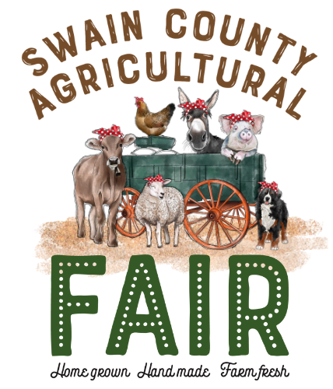
SWAIN COUNTY AGRICULTURAL FAIR
Saturday, August 19, 2023

Farm Product Entry Form
Honey

Name: _______________________ Address: _______________________________ Phone #: ___________________ E-mail: ___________________________________

Honey Extracted |  | Honey Chunk
Light or Dark | # of jars | Light or Dark | # of jars

Exhibits Received: Monday and Tuesday, August 14 & 15 between 9:00 a.m. to 4:00 p.m.
Location: Swain County Cooperative Extension on 60 Almond School Road, Bryson City, NC
(Any entry received after these dates will not be judged)

Exhibit Pick-up: Monday, August 21 between 9:00 a.m. – 4:00 p.m. at the Swain County Cooperative Extension.
For more information, contact:
Minda Daughtry. Agriculture/Horticulture Agent
(828) 488-3848 OR minda_daughtry@ncsu.edu

