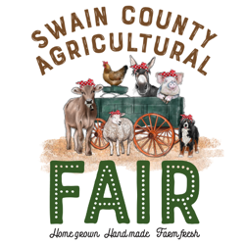
Swain County Agricultural Fair
Saturday, August 19, 2023
Youth Division Entry Form
Arts & Crafts, Baked & Canned Foods

Youth’s Name: ____________________________________ Youth’s Age: _______
Address: ________________________________________ Phone #: ___________ Parent’s Name: ______________________________ E-mail: __________________

Division: A, B, C or D | Class: 1, 2, 3, 4, 5, 6, or 7 | Category #

Entry Check-in
Monday and Tuesday, August 14 & 15: 9:00 am – 4:00 pm
(any entry received after these dates will not be judged)

Entry Pick-up
Monday, August 21: 10:00 am – 4:00 pm
(unless items will be entered in the Mtn. State Fair & picked up by the Pony Express)

For more information, contact:
Kristi Griggs, Extension Agent, 4-H Youth Development
(828) 488-3848 OR kristi_griggs@ncsu.edu

